|  |  |
| --- | --- |
| Course Name | ITD 2313 – Script Programming |
| Instructor | Mark Pranger |
| Student Name | Josh Jones |
| Due date | <assignment due date here> |
| Grade | <grade earned here> |
| Grading Comments | <instructor comments here> |

Project #1:

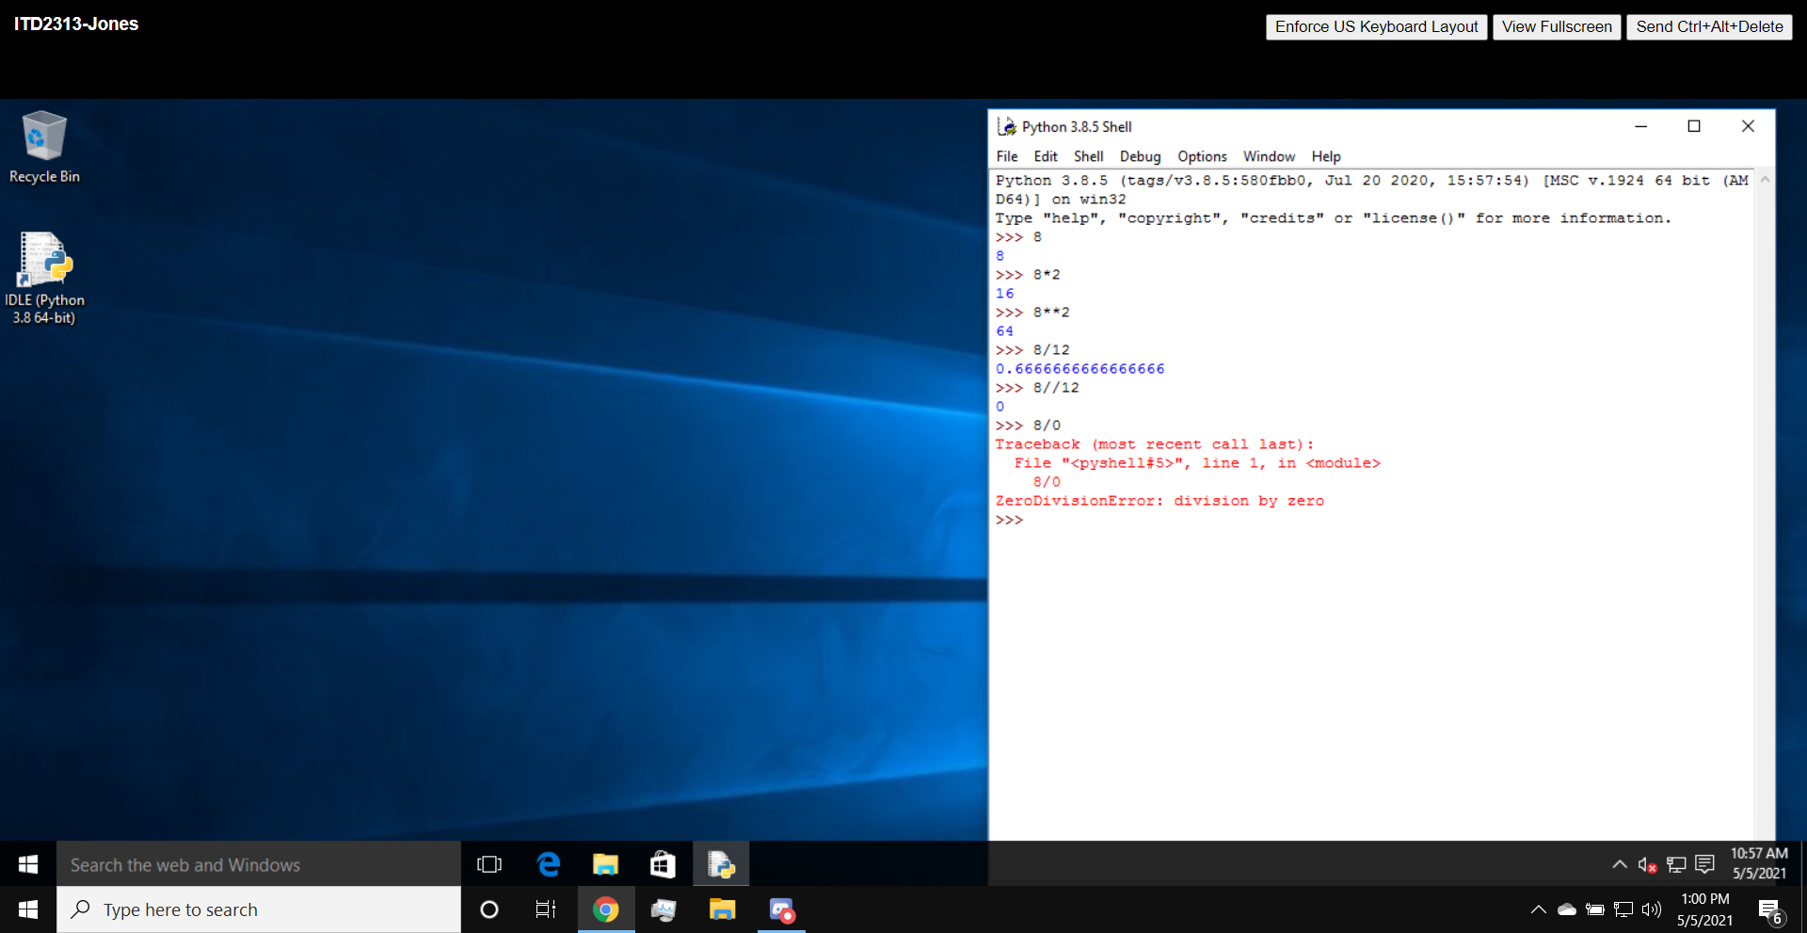

Project #2:

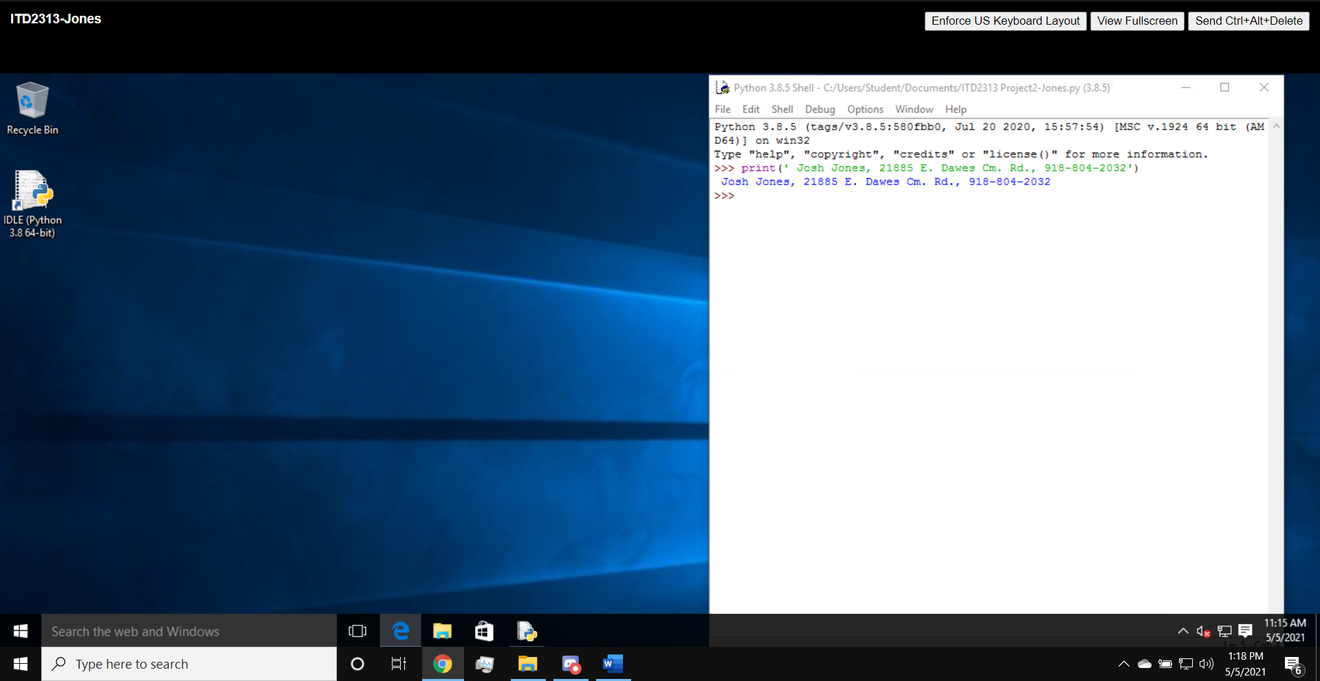

Project #3:

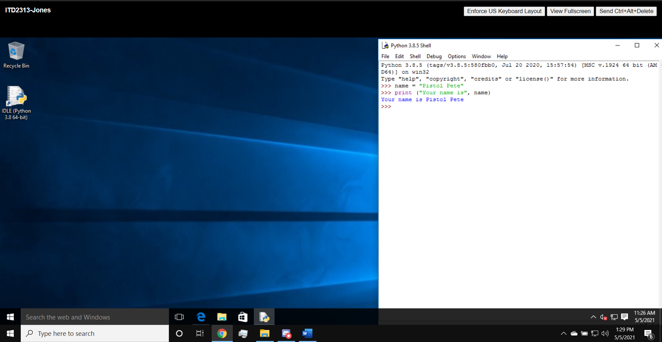

Project #4:

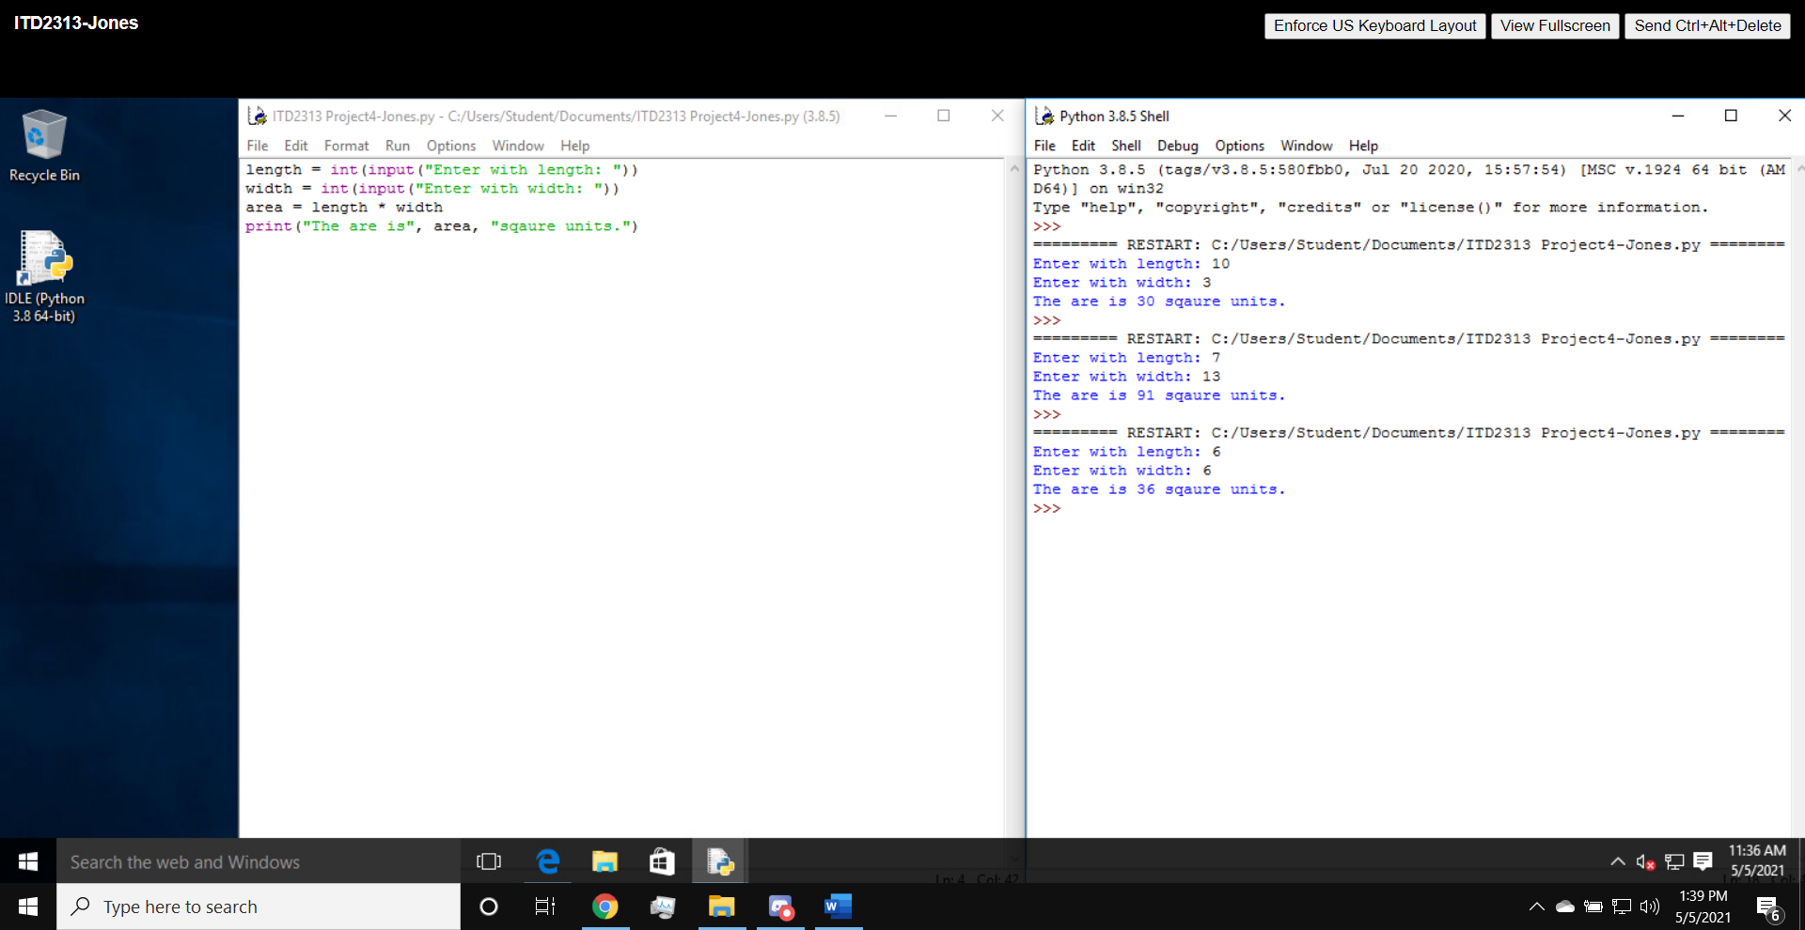

Project #5:

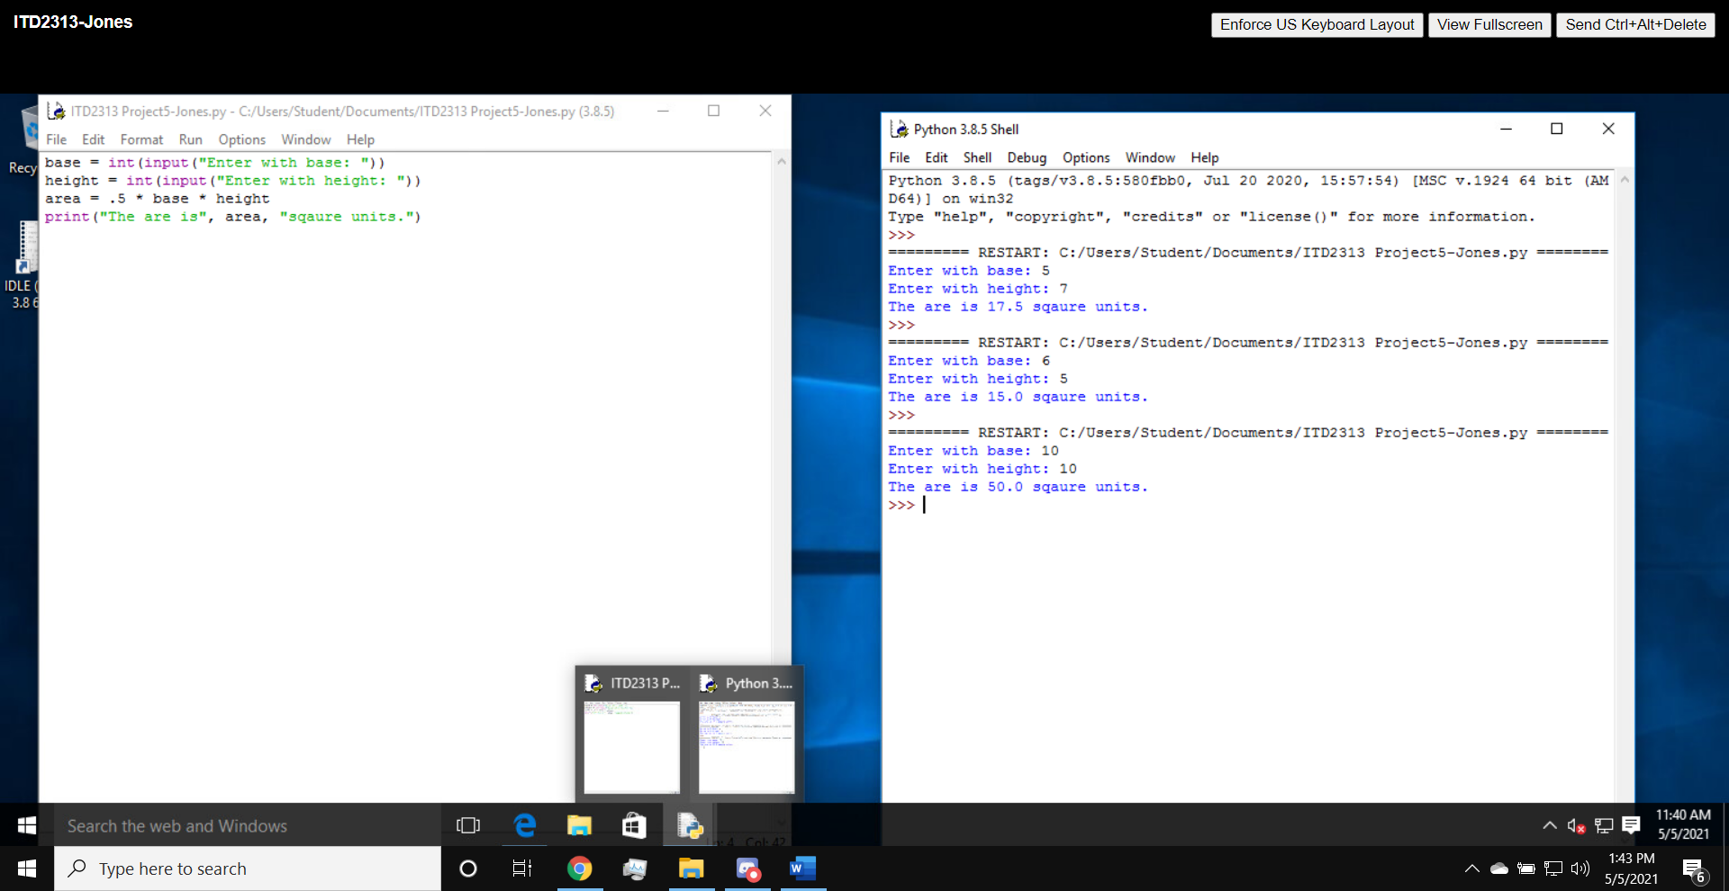

Project #6:

